Safety Plan for Trail Maintenance by Volunteers

Contents

Introduction 2
Volunteer Work Bee Trip Plan 3
General Safe Practices for Trail Workers Operating any Kind of Tools 3
Volunteer Crews Operating Manual Equipment 4
Certified Volunteer Crews and Hired Crews Using Power Tools 4
Training & Insurance 5
Training for Trail Maintenance of all Crews 5
Insurance 5
Training Plan for Chainsaw Operators 5
Long Term Goal 5
Personal Protective Equipment for Power Tool Use 5
First Aid for Volunteer and Hired Crews 6
Record Keeping and Follow Up 7
Resource, Links, Contacts & Acknowledgements 7
Useful Links for Trail Standards: 7
Contact Information for <<YOUR CLUB NAME>> 7
Acknowledgements: 7
Resources and Links 7
Sample Work Bee Form 8
Sample Safety Meeting Checklist 9
Sample Emergency Plan 10

Introduction

This safety plan is provided by the <<YOUR CLUB NAME>> and sets out guidelines for volunteers that wish to participate in trail maintenance work days. It illustrates our commitment to safety and general practices for trail maintenance. References include:

- Canadian Centre for Occupational Health and Safety (OHS guidelines)
- Work Safe BC
- BC Forest Safety Council
- BC Provincial Parks

There are 3 types of crews:
1. Volunteer crews using manual tools only
2. Volunteer crews that are certified to use power tools, i.e. Chainsaws and brushing saws
3. Hired/ contracted crews of equipment operators for power tools and machinery, with GL insurance

1. Volunteer Crews - these crews are comprised of a minimum of 2 or more that wish to participate in the upkeep of the trail systems. They will use only simple, manual, non-motorized tools such as shovels, picks, trimming shears, loppers or hand saws. Their work shall be coordinated by a <<YOUR CLUB NAME>> member and follow the Annual management/work plan. A <<YOUR CLUB NAME>> Work Bee Coordinator shall be appointed and present at each session to offer and monitor for the safety guidelines recommended here.

2. Volunteer Crews certified to use power tools - these crews are comprised of a minimum of 2 or more trail users that have been certified by the Forest Safety Council or recognized as having the necessary skills and experience by the Land Manager. They will operate power tools for brushing, limbing and bucking only. A <<YOUR CLUB NAME>> Work Bee Coordinator shall be appointed and present at each session to offer and monitor for the safety guidelines recommended here.

3. Contracted Trail Crews or Equipment Operators - these crews will be chosen by <<YOUR CLUB NAME>> according to the job and qualifications needed. The Land Manager shall also be a part of the process and contract approval must follow Land Manager contracting guidelines. A Coordinator shall be appointed to present the safety guidelines recommended here and periodically monitor adherence.

NOTE - As a courtesy and management tool all work bee days should also be coordinated with the Land Manager so they can incorporate this into their staff schedules. We can help Land Mangers by identifying conditions that require work and then pass that info along with photos and GPS information, so that they may take this into consideration when prioritizing and scheduling work by their staff.

Volunteer Work Bee Trip Plan

Each trip plan (whether 1 or more people) should have the following components.

TASK | DESCRIPTION | SEE PAGE
Sign In & Sign Out | All crew members must sign in with coordinator at the beginning of the day and sign out on paper at the end | See page 9 for a sample form
Pre Trip Safety Meeting | The Coordinator provides a short briefing about the day’s work such as the type of work being done, weather assessment, wildlife, man checks and safety procedures as needed | See page 10 for a sample sheet
Communication | If separated each crew group should have a communication device and there should be a plan in place for contact times
Emergency Plan | An emergency plan should be developed before the workday. This should include contact numbers for the nearest hospital, Search and Rescue, and 911. In the case that equines are used an emergency veterinarian number will be helpful | See page 11 for a sample plan
First Aid Kit | A suitable First Aid Kit shall be available for each work party. Crews that operate power tools should meet First Aid requirements as outlined by OHS and WorkSafeBC standards | See page 6-7 for requirements when using power tools
Personal Protective Equipment | Volunteers using non-power tools are expected to have appropriate hats, gloves and footwear as well as clothing suited to climate and work they are doing. Certified Power tool operators should wear gear as specified by OHS and WorkSafeBC standards | See page 5-6 for description

General Safe Practices for Trail Workers Operating any Kind of Tools

- Only use equipment that you have adequate training, experience and knowledge to operate whether that be powered or non-powered equipment
- Practice safe tool use, storage, maintenance and transportation
- Let someone know where you are going and when you plan to return. Sign in and sign out
- Develop an emergency plan for the area you are working in
- Provide an itinerary to a responsible person that you plan to check in with periodically and at the end of your day
- Work with a partner and never alone whether using power equipment or not
- Plan ahead and prepare for changing weather conditions
- Check trail conditions before setting out
- Have a communication device with you at all times (cell, satellite phone, or 2-way radio) and a first aid kit
- If unsafe work is observed the crew will be asked to stop work. Anyone on the crew can stop work. The objective is to reassess and/or quit the activity until the issue is resolved
Volunteer Crews Operating Manual Equipment

Activities undertaken by these volunteer crews include brushing, repairing/building boardwalks and bridges, maintaining water bars, rerouting trails as directed, maintaining slopes on trails, directing water off trails, erecting signage, inventory, monitoring, and other jobs that do not require power tools. No specialized training is needed for volunteers. They will be operating basic tools like garden shears, loppers, shovels, hammers, rakes, and hand saws as needed for the job.
It is recommended that participants bring work gloves, long sleeve shirts, pants and shoes appropriate for hiking (or riding) and working. Hats, sunglasses, sunscreen, bug spray, and rain gear are also to be considered. Volunteers should also bring their own water and snacks unless otherwise directed.
At least one member of each crew should have Basic First Aid Level 1 and a basic First Aid Kit should be with each crew. Each person on the crew should know where this Kit is located.
By partnering with Land Mangers, <<YOUR CLUB NAME>> will endeavor to provide some trail building training skills such as:

- Applying appropriate Trail Standards
- Danger Tree Assessment
- Weed Identification
- Proper Equipment Use
- First Aid
- Power Tool Use
- Conducting Safety Meetings

Certified Volunteer Crews and Hired Crews Using Power Tools

Volunteer Crews and Hired Crews that operate power equipment are expected to have training and certification to operate safely within the guidelines specified by OHS and WorkSafeBC. Training must be provided by an acceptable organization such as the BC Forest Safety Council. Operators of power tools used to construct or maintain trails and facilities (e.g. chainsaw operators) must show proof of Basic Chainsaw Operator Training course or equivalent. These Volunteers or crews will do limbing and bucking ONLY. They will not be felling trees.

A copy of the Operator’s certification is to be placed on the project file prior to the work bee. If they don’t have a certification but you know that they have the competency based on prior years working with them or for some other reason, document this “equivalency” in the file prior to the work bee. If you are unable to document certification or equivalency, then that individual will not be able to operate a chainsaw or power tool while on that project. The project file should be kept for 3 years.

Crews and/or Volunteers must show competency with any other power tools used (i.e. skill saw, brush cutters, power operated pruners, lawn mowers) or motorized equipment such as ATV’s, Gators, or Side by Sides. Any volunteers or crew members who accompany a person operating a power tool must understand safety requirements such as staying back at least 10 feet (3 meters) from the operating area. Any certified person operating a power tool or accompanying the operator is expected to wear Personal Protective Safety gear as specified by WorkSafeBC and OHS guidelines and shown in Figure 1 below.
Training & Insurance

Training for Trail Maintenance of all Crews
Trail works will be conducted in accordance to the Land Managers standards for Trail Maintenance. At the very least these standards should be reviewed and discussed at the pre-trip safety meeting. A suggested reference book is: Trail Solutions: IMBA's Guide to Building Sweet Single track. Training courses may be coordinated with Land Mangers and other stakeholders.

Insurance
Volunteers are encouraged to carry their own personal medical insurance.

Training Plan for Chainsaw Operators
Preparation | Review WorkSafeBC materials and videos; review CCOHS website for chainsaw operation Regulation 8.7, 8.9. Before purchasing a chainsaw note safety feature requirements*. Register for accredited course. Work alongside certified operator
Certification | Attend and pass course with BC Forest Safety Council or other accredited course recognized by WorkSafeBC, or be assessed by a Staff person. Provide a copy of certification to the Land Manager and stakeholder group. Obtain required personal protective equipment.
First Aid | Get First Aid Training such as St. John Ambulance or Red Cross OFA Level 1
Record Keeping | Maintain records as specified in course. Provide records to the Land Manager and stakeholder group to monitor work completed
*Chainsaw Safety Features: must have chain brake, chain catcher, throttle trigger lock, whistle, axe, wedge, pressure bandage, and fire extinguishing means

Long Term Goal
Our long term plan is to have several Certified Operators, who can in turn, attract assistants that wish to become certified. A trained and experienced crew recognized by the Land Manger will be able to efficiently clear and repair trails which will benefit all trail users.

Personal Protective Equipment for Power Tool Use
Figure 1
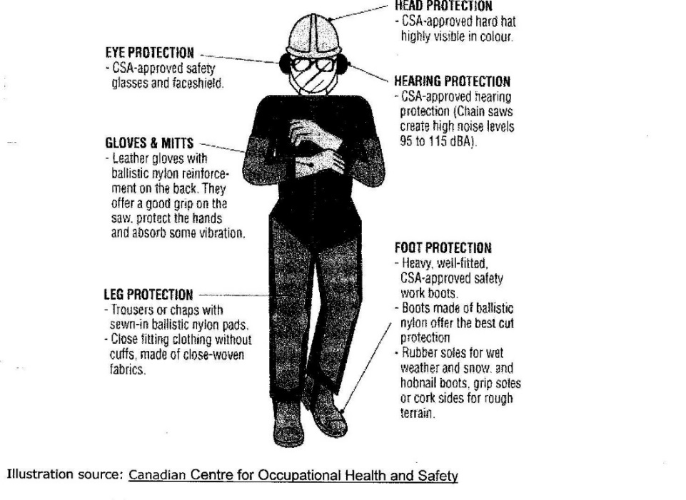

Summary of Personal Protective Equipment (PPE) when Operating Power Tools
Minimum PPE required | Chainsaw | Power Brush Cutter | Power Pruner
Hard Hat | Yes, CSA approved | Yes, CSA approved | Yes, CSA approved
Ear Protection | Yes, muffs or ear plugs | Yes, muffs or ear plugs | Yes, muffs or ear plugs
Face and Eye Protection | Face screen mandatory, safety  glasses mandatory | Yes Face Screen Mandatory | Face screen mandatory,  safety glasses optional
Gloves | Yes, leather or cut resistant | Yes | Yes
High Visibility Vest or Jacket | Yes, must have 120 sq inches on front and back, worn over contrasting color | Yes, must have 120 sq inches on front and back, worn over contrasting color | Yes, must have 120 sq inches on front and back, worn over contrasting color
Leg Protection | CSA approved pads or pants (OHS Reg 8:21 ad Standard 1-1997) | Leather, nylon or canvas | CSA approved pads or pants (OHS Reg 8:21 ad Standard 1-1997)
Protective Footwear | Must provide ankle support. CSA approved safety work boots with cut protection | Leather boots | Must provide ankle support. CSA approved safety work boots with cut protection
Training required | OHS/WorkSafeBC or approved by Land Manager Staff | No certified training required  Training by peers | No certified training required  Training by peers

First Aid for Volunteer and Hired Crews

This table outlines the First Aid requirements from Occupational Health and Safety Regulations 3.21
<<YOUR CLUB NAME>> recommends teams of at least 2
Check for updates at: Schedule 3-A Minimum levels of first aid

Risk & Distance from Medical Facility | # of Crew Members | Supplies & Equipment | Level of First Aid Certificate for Attendant | Transportation
Low Risk of Injury  more than 20 min from hospital | 1 | Personal First Aid Kit | 1st Responder
 | 2-5 | Basic First Aid Kit | 1st Responder
 | 6-30 | Level 1 First Aid Kit | Level 1 Certificate
Low Risk of injury, less than 20 min from hospital | 1 | Personal First Aid Kit | 1st Responder
 | 2-10 | Basic First Aid Kit | 1st Responder
 | 11-50 | Level 1 First Aid Kit | Level 1 Certificate
Moderate Risk of Injury, more than 20 min from hospital | 1 | Personal First Aid Kit | 1st Responder
 | 2-5 | Level 1 First Aid Kit | Level 1 Certificate
 | 6-15 | Level 1 First Aid Kit  ETV equipment | Level 1 Certificate with transportation endorsement
Moderate Risk of Injury, less than 20 min from hospital | 1 | Personal First Aid Kit | 1st Responder
 | 2-5 | Basic First Aid Kit | 1st Responder
 | 6-25 | Level 1 First Aid Kit | Level 1 Certificate
High Risk of Injury, more than 20 min from hospital | 1 | Personal First Aid Kit | 1st Responder | ETV
 | 2-5 | Level 1 First Aid Kit | Level 1 Certificate
 | 6-10 | Level 1 First Aid Kit  ETV equipment | Level 1 Certificate  With transportation endorsement
High Risk of Injury  less than 20 min from hospital | 1 | Personal First Aid Kit | 1st Responder
 | 2-15 | Level 1 First Aid Kit | Level 1 Certificate
 | 16-30 | Level 2 First Aid Kit, dressing station | Level 2 Certificate

Record Keeping and Follow Up
Please see pages 9 & 10 for a sample work bee record and safety meeting checklist. At the very least a written Trail Maintenance Record should contain:

- names of coordinator (s) and participants
- hours spent
- types of tools used
- location of work site and jurisdiction
- trail conditions
- work completed
- any follow up actions needed

<<YOUR CLUB NAME>> can provide information to the permitting organization about trail conditions and any other hazards beyond the crews’ ability. When working on trails we are able to identify conditions which may require future work and thus be the eyes for Land Managers. Our long range plan will be to identify and suggest future improvements to the trail systems.

Resource, Links, Contacts & Acknowledgements

Useful Links for Trail Standards:
Trent University Trail Standards:
www.trentu.ca/academic/trailstudies/standards.html#equestrian

BC Ministry of Forests:
www.for.gov.bc.ca/hfp/publications/00201/chap10/chap10.htm#s10.3.5

Squamish Trail Standards Manual
http://www.squamish.ca/assets/Trail-Standards-Manual-0411.pdf

Contact Information for <<YOUR CLUB NAME>>

Acknowledgements:
Many thanks to Back Country Horsemen of BC, Mountain Madness, and Friends of Manning Park for allowing us to use their content suggestions when producing this safety document.
More info on Mountain Madness can be found at: http://www.mountainmadness.ca/ or email: mountainmadness@telus.net

Resources and Links
Canadian Center for Occupational Health and Safety (OHS) Regulations: 8.7 and 8.9
WorkSafeBC - Workers Compensation Act 115 and 116
BC Forest Safety Council
BC Parks: Volunteer Program and Trail Standards for Maintenance

Sample Work Bee Form

Work Bee Attendance Record and Waiver for <<YOUR CLUB NAME>>

Date:____________________ Location: ____________________________________
(trail name)

Coordinator:_______________________________

Volunteers Attending
Check in Signature | Phone number | Hours | Check out Signature

Waiver - please have each Volunteer or Crew member read this statement before signing
By signing this waiver and in consideration of my acceptance of this activity for myself, executors, administrators and personal representatives release the organizers of these events, their agents ad volunteers and the event’s sponsors from all liability and I waive as against the organizers, agents, volunteers and sponsors, all claims whatsoever that I might have for personal injuries, death, property losses, or property damage suffered by participating in this event.

Sample Safety Meeting Checklist

- all volunteers and crew members have signed in and read the waiver
- Identify leaders
- Discuss trail work to be done
- Discuss hazards and safety issues regarding the type of tools being used
- Discuss hazards and safety issues regarding trail conditions and wildlife
- Do a weather assessment
- Discuss First Aid and Safety plan including communication and man checks
- Check for PPE
- Do periodic checks on safety compliance
- All volunteers and crew members have signed out

Type of Crew (check one)

___Volunteer Manual Crew ___Volunteer Power Crew ___Hired Power Crew

Notes on Trail Conditions:

Notes on Work Completed and Follow Up Actions:

When completed Coordinator to sign off here:

Date: ________________

Name: ______________________________________________________

Sample Emergency Plan

Safety Plan for <<PROJECT NAME>>

Start and End Dates:

- A review of potential job-specific hazards will take place and any identified hazards will be addressed prior to the start of the project.

- A safety orientation will be held for all participants prior to the start date.

- List any Public Safety Considerations and closures of trails or park areas.

- A First Aid Kit and a person with a current First Aid Certificate will be present at all projects and events.

- At least one person will have a cell phone or radio and an emergency contact list at all projects and events.

Emergency Contacts:
Police/Fire/Ambulance Emergency | 911
BC Hydro (Emergencies) | 1-888-769-3766
RAPP (Report All Poachers and Polluters) | 1-877-952-7277
Report a Forest Fire | 1-800-663-5555
Air or Marine Emergency | 1-800-567-5111
Poison Control Centre | 1-800-567-8911
Nearest Hospital <<Hospital Name>>
Local Search & Rescue
Local Community Police

Non-Emergency Contacts:
Land Manager <<Staff Persons Name>>
Park Facility Operator
Local RCMP Detachment

